**MLOI Capability Study Analysis**

Prepared by Rick Ales, R Ales Consulting LLC, 7/2/2025 for Allen Aircraft Products, Inc.

Updated 7/10/2025 V3

**Scope**

This document summarizes the capability study of the Multi-Oil Level Indicator (MLOI) Automated Test Bench specifically for the AAP Elevate OLS based on the calibration procedure, specified in clauses of Section 5.2 of the *Qualification Test Procedures for the Multi-Oil Level Indicator, Automation of the OLS Test Bench* AAP Report 250318 (QTP)

5.2 Performance Requirements Test Procedures 36

5.2.1 Capability A1 - Level Calibration Repeatability & Accuracy 37

5.2.2 Capability A2 - Resistance, Calibration, Repeatability & Accuracy 41

5.2.3 Capability A3 - Resistance Stability and Drift 44

The purpose of this report is to present the statistical analysis of the experiment to study the calibration and gage error performance of the LabVIEW (LV) automated Acceptance Test Procedure (ATP) an Oil Level Sensor (OLS) referred to as Multi-Level Oil Indicator (MLOI) and determine the best system calibration.

**Calibration Factors & Findings**

Based on the analysis herein, the following is a table of the best, unbiased estimators of the calibration factors.



* Level Repeatability is 0.0054”
* Level Reproducibility is NOT significant
* Ch A Resistance Tolerance is ±0.11%
* Ch B Resistance Tolerance is ±0.23%
* Current source drift is NOT significant.

# **Level Calibration**

**Executive Summary**

A modified gage error study was performed to characterize the calibration of the reported level from the laser gage instrument to a mechanical depth gage reference. The study showed that the depth measurement is a simple linear function of the laser value with no evidence for nonlinearity. The slope between the mechanical measurement and the laser measurement is slightly biased away from the expected 1:1 relationship. The *Repeatability* (i.e. random noise in the measurements) was determined to be 0.0054 inches.

Level calibration is susceptible to human error, so any difference in operators is an important consideration. Reproducibility (i.e. the random effect of Operator) was determined to be insignificant for a trained, experienced operator.

***The combined Reproducibility and Repeatability variation is 0.0054 inches at 99% confidence****.*

**Purpose**

The purpose of this section is to present the statistical analysis of the experiment to study the calibration and gage error performance of a measurement of fluid depth for an Oil Level Sensor (OLS). The MLOI LabVIEW (LV) program uses two correction factors: Slope and Intercept scale/calibrate the laser output to match the readings obtain by measuring the distance between the OLS datum and the actual oil level in the test tank. These calibration/correction factors are applied to the laser output to determine oil level during ATP testing.

This analysis has two parts: first, the regression analysis of the full data set to determine the best unbiased estimator of the true calibration; second, analysis of *Trials* defined as a group of 5 measurements over tank EMPTY to FULL span considered a Calibration check that an operator would perform prior to running an ATP test in production. *Trial* has is often referred to as a *5-Point Calibration*.

**Aggregate Experimental Data**

The experimental data were collected using the LV MLOI Level Calibration routine (See QTP) A total of 60 individual measurements resulting in 3 calibrations by each of the 4 operators for a total of 12 individual calibrations. See Table 1. Aggregate Experimental Data with the following definitions:

* The Operator who collected the data is shown in column *Op* and the dates when the data were collected are shown in column *DateTime*.
* Columns *Op* and *DateTime* were combined into a composite column named *Trial* that will be used as the source of reproducibility variation.
* The *Setpoint* is the nominal, uncorrected target oil levels value where each of 5 measurements are made over the range of levels from EMPTY to FULL. The level is allowed to settle for at least 6 seconds prior to asking the Operator to make the mechanical level measurement.
* Column *Index* (1 to 5) is just the ID number of the setpoint level.
* *Laser^2* is equal to Laser x Laser used to check for 2nd order effect and non-linearity.
* *Laser* is the recorded reading of the LK-G3000 Laser Depth Gage output after allowing the tank oil to settle for at least 6 seconds.
* The mechanical depth gage measurements are reported in column *Measure*.

**Statistical Analysis**

All graphical and statistical analyses were performed using MS Excel 365, with Data Analysis package, see *MLOI:\$Calibration\$MLOI_CalRecord v3.xlsx*

Figure 1 shows the scatterplot of *Measure* as a function of *Laser*. *Measure* appears to be a simple linear function of *Laser* with ‘fit trendline’ yielding the follow relations whose coefficients are the best, unbiased estimator of the true calibrated slope and intercept (aka offset) correction factors.

$$Measure=9.5983-0.997 x Laser$$

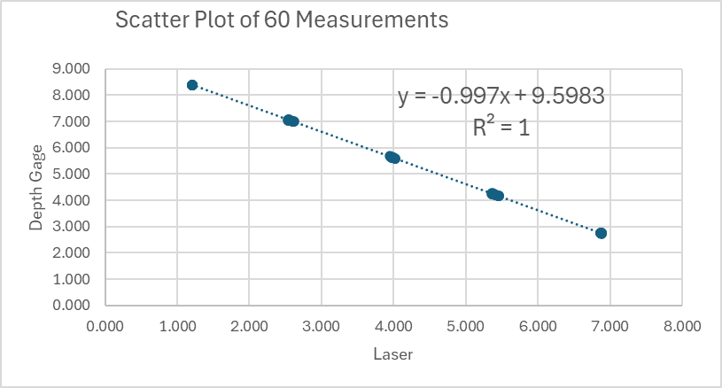

Fig 1 Scatter Plot of Full Measure v Laser Data Set

Figure 2 shows the full Regression model for of *Measure* as a function of *Laser, OP, OP*Laser,* and *Laser^2. OP* was included in the model as a random qualitative factor while the other values were included as continuous covariates. The quadratic terms for *Laser* and the *OP*Laser* interaction were also considered in the initial model for the sake of completeness.



Fig 2. Initial Regression Analysis Results

The model shows that:

* The *Laser2* term is not statistically significant (p = 0.031) which indicates that *Measure* is a simple linear function of *Laser*.
* The *OP*Laser* term is not statistically significant (p = 0.211) which indicates that the slope of *Measurement* versus *Laser* is homogeneous across *OP*.
* The *OP* term is not statistically significant (p = 0.190) which indicates that the standard deviation of the random biases between trials is not different from zero.

Although not statistically significant in this analysis, examining the residual plot of the OP factor (Fig 3) appears to show a larger deviation (with potential outliers) from the best estimated calibration in operator #3, while operator #1 showed a slight positive bias compared to the other operators. These slight variations attributed to human nature should be expected and should be considered in the development of the final system calibration scheme.

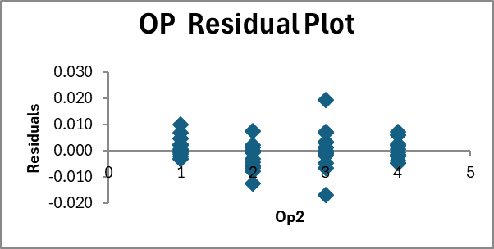

Fig 3 Operator/Reproducibility Effect

Re-running the regression analysis excluding insignificant terms except retaining the *OP* factor as the Reproducibility component found in a typical Gage R&R study, the model with complete ANOVA results is shown Fig 4.



Fig 4 Aggregate Data Set Regression Analysis

Analysis of the Residual plot (Fig 5) shows residuals are normal and homoscedastic as required by the ANOVA method. There is evidence of two indicated outliers, both from Operator 3 (previously indicated as having the most variance i.e. least experience) in Trial #2, lending credence for excluding this *Trial* from further analysis.

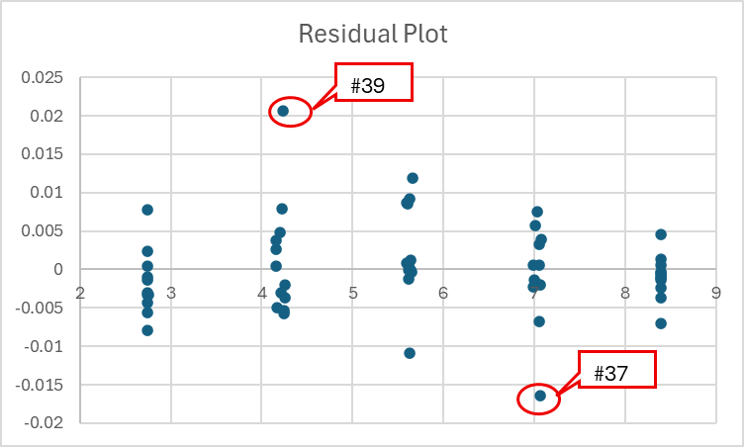

Fig 5 Aggregate Data Set Regression Residuals



**Conclusion**

The *Measure* response is a simple linear function of *Laser* with no indication of nonlinearities or *OP* effects. The best, unbiased estimator of the true calibration is:

$$Measure=9.5975-0.9965×Laser$$

**Slope Compared to Unity**

As a side note, the slope coefficient can be tested to see if it differs from its expected value -1.0 using Student’s t test. The test’s t statistic is

$$t=(-0.9964-1.0)/0.0015=2.45$$

which is statistically significant (p = 0.025), so the slope is biased slightly from its target value of 1.0 used in the original MLOI ATP Test Bench.

**Table 1. Aggregate Experimental Data**





**Calibration Experimental Data**

The experimental data is the organization of 5 consecutive runs over the tank EMPTY to FULL span of the Aggregate Data into *Trials* aka 5-Point Calibrations resulting in 12 *Cal IDs* The EMPTY and FULL end point are fixed while the intervening quintile set points have a ± 0.100’ random value added to the nominal Set Point to help eliminate any human bias in the depth *Measuremen*t. The Calibration Experimental Data is displayed in Table 2.

**Table 2 Calibration Data**



The new column definitions are:

* *Cal ID* is the number of the specific 5-Point Calibration.
* *Goodness* the maximum residual resulting from the regression of the 5-Point Calibration.
* *Slope* the coefficient of the 5-point regression slope
* *Intercept* the coefficient of the 5-point regression intercept.
* *Slope Dev* the maximum deviation of *Slope* from the average of 12 *Slopes*
* *Int Dev* the maximum deviation of *Intercept* from the average of 12 *Intercepts*

Conditional formatting is set to highlight abs(*Slope Dev*) > 0,002 and abs(*Int Dev*) > 0.005. Note that *Cal ID* #8 contains the data points indicated as outliers in the Aggregate Data analysis and is excluded from further analysis. A plot of the *Slope* and *Intercept* values vs *OP* and *Trial* of Fig 6 shows further justification for excluding Cal ID #8 from the analysis as Operator #3 Trial #2 is significantly different from the other measurements.

Fig 6. Calibration Factors vs Operator and Trial

**Calibration Analysis**

The calibration is analyzed more like a typical Gage R&R, having 4 operators and 3 replicate measurements. However, since the is only a single tank system, the Part variation factor typically reported in a Gage R&R is not available for analysis. Therefore, the analysis presented consists of calculating the Upper and Lower Confidence Limits (UCL and LCL) of the *Slope* and *Intercept* and using these limits to define the Measurement Uncertainty Interval (MUI). These results, excluding *Cal ID* #8, for 90% and 99% confidence limits are shown in Fig 7 thru Fig 9.

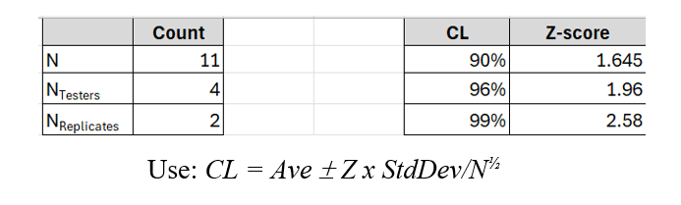

Fig 7 Evaluation of Confidence Limit (CL)



Fig 8. Evaluation of Level Calibration Factors at 90% Confidence Limits



Fig 9 Evaluation Level Calibration Factors at of 99% Confidence Limits

Using this method would suggest the best, unbiased estimator of the true calibration is:

$$Measure=9.5974-0.9969×Laser$$

Which is within close agreement of the aggregate analysis:

$$Measure=9.5975-0.9965×Laser$$

Therefore, use Slope = -0.997 and Intercept = 9.597 as calibration factors to scale the laser output as the laser output as the recorded ATP *Level* value.

**Reproducibility**

Reproducibility or the difference in measurement caused by operator factor, is analyzed by performing a single factor ANOVA based hypothesis test at both the *Slope* and *Intercept* coefficients where:

H0: There is no reproducibility difference between operators.

HA: There is a significant difference between operators.

Based on the ANOVA tables shown in Fig 10, the null hypothesis (H0) **cannot** be rejected at the 95% confidence level in either case as p-value is >> 0.005.



Fig 10. Reproducibility Hypothesis test ANOVA Table.

**Measurement Error Risk Mitigation**

There are two types of errors:

* Type I Error is a false positive, Accept a Bad part. (detrimental to the customer)
* Type II Error is a false negative, Reject a Good part. (detrimental to the supplier)

In the MLOI system these are illustrated in Fig 11 where the blue line indicates the specification test limit and Test Point (TP) indicates the actual point was the measurement was observed that can be located anywhere within the Measurement Uncertainty Interval (MUI). The recommended test strategy to minimize risk to the customer to include a buffer zone based on MUI that minimizes the likelihood of a Type I Error. This strategy is illustrated in Fig 12. The orange line represents the OLS response in Ohms to the indicate level (Blue arrow). The Target Test Point is set so a RNG_Stop value such that the maximum bound of the MUI does not exceed the product specification, thus minimizing possibility the measurement will allow a Type I Error. However, the trade off is the increased likelihood of a Type II Error and that a good part would be rejected. The recommendation is for the supplier to institute a discrepant materials procedure that allows for the retest and re-qualification of an initially rejected part so to minimize the negative impact of Type II Errors and production costs of discarding a good part.

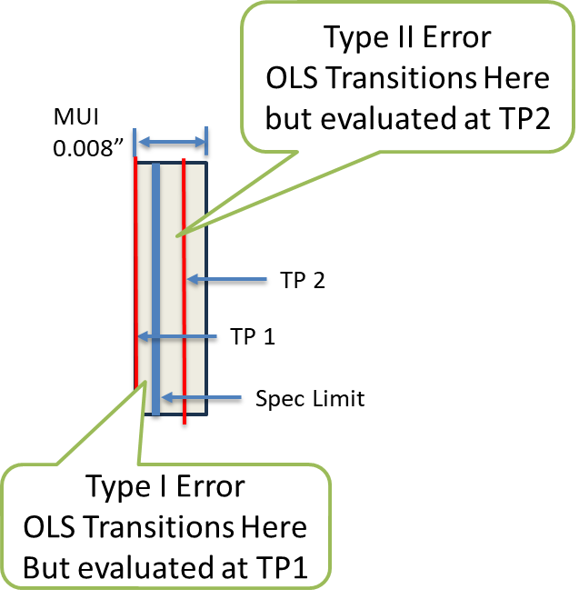

Fig 11 Error Types & MUI definition

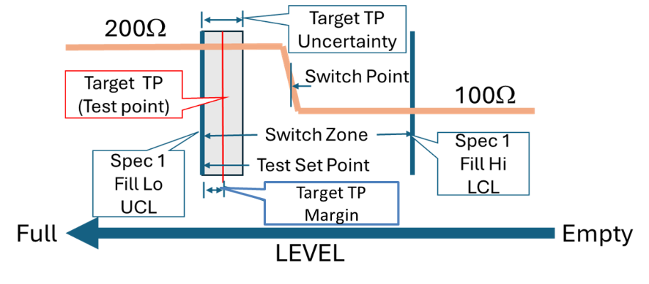

Fig 12. Type 1 Error Risk Mitigation Strategy

**Level Calibration Strategy**

The degree of random variance observed in the above analysis suggest re-calibrating the system to a single 5-Point Calibration sample would likely introduce unwanted variation and potentially measurement errors into the ATP results when the underlying true calibration remains unchanged.

Because of the uncertainty inherent to the calibration procedure, a full calibration of at least 3 trials with two operators should be performed at least annually unless other indications identified by the Quality Department warrant more frequent full calibration. Any instrument used in the calibration process should be independently calibrated to a NIST traceable source, per the AAP Quality Management System. The result of the Full Level Calibration becomes the *Slope* and *Intercept* level calibration factors to be included in the MLOI LV system configuration file for use to determine the ATP recorded Test Levels.

Yet steps must be taken to ensure the ATP is providing accurate test results. The MLOI LV system will implement the following calibration algorithm as the best practice to mitigate calibration risk:

1. Upon the first run of the day, the MLOI LV tester will ask the operator to perform a 5-point level calibration and launch the calibration application.
2. The system will compare the results of the daily calibration to the configured *Slope* and *Intercept* calibration factors allowing the test to proceed if the difference is less than the prescribed deviation allowance.
3. Otherwise, the operator will be instructed to seek consul from the Quality Department as to how to proceed.
4. The Quality Department shall have the ability to modify the calibration verification criteria.

# **RESISTANCE Calibration**

**Executive Summary**

Resistance is calculated based on Ohm’s Law applied to a calibration current source and a voltage measurement made by DataQ DI-2108 compared to 100Ω and 1KΩ 0.01% 15ppm reference.

Chanel A and Channel B have independent current sources nominally set to 14.7ma used to calculate resistance using Ohms Law. The resistance measurement channels are calibrated automatically by the LV Resistance Calibration procedure to an accuracy of better than 0.5%.

**Procedure:**

The LV Resistance Calibration procedure instructs the operator to attach the leads to each of the reference resistors, then indicate the leads are attached as instructed. The procedure then records the data for each measurement, calculates the best fit Slope and Intercept for the two reading then producing the output shown in Fig 13 which is saved in the calibration record.



Fig 13 Resistance Calibration Recorded Data.

**Repeatability:**

This procedure was repeated four times resulting in the table of calibration factors shown in Fig 14.



Fig 15 Table of Resistance Calibrations

Analysis of the Calibration data by channel based on variation/deviation from the channel averages is shown in Fig 16 and Fig 17.

 Fig 16 Channel A Calibrated Tolerance



Fig 17 Channel B Calibrated Tolerance

**Current Source Drift**

This Test of the DataQ with the breadboard PCB version Q01 which has 1% resistors. The current is measured as the voltage across a 100Ω 0.01% 15ppm TCE reference metal film resistors with DataQ and PicoScope. The actual current is measured with the calibrated production Fluke (Fluke 14ma Prod) used as an ammeter on the mA scale.

Engineering Fluke 0mA measurement was with the probes shorted on the mA scale.

DataQ voltage data was collected using WinDaq recording software with a 0.6 scale factor to account for the 1K 1% over 1.5K 1% scaler.

The test was run in the Production Lab from 3/27 to 4/1 for a total of 115hours. The 99.7% tolerance is the +/- 3-sigma range where 99.7% of all measurement will fall within this range as shown below, (ref: *Five Fluke - Engineering Design Review Platform for Modern Hardware Teams).* The distribution of measurements for the DataQ indicate a resolution of about 50μV

The results are shown in Fig 16 thru Fig 18.



Fig 16 Fluke 0A reference



Fig 17 Fluke 14.7ma product test over 115 hrs.



Fig 18 Both Channels measure with the DataQ @ 14.7ma over 115 hrs.

**Conclusion**

* Resistance measurement and calibration is straightforward yielding a tolerance better than 0.5%
* Current source drift is NOT significant.

END OF DOCUMENT